**💊 Pharmacy OTC Sales Analysis Report (2022)**

**📌 Introduction**

This analysis explores simulated sales data of over-the-counter (OTC) pharmacy products collected across several countries during **January–August 2022**. The dataset covers key attributes such as product names, salespersons, units sold, transaction amounts, and countries.

Our goal is to **identify market patterns, top contributors, and potential growth opportunities** by examining sales trends over time, across regions, and by product category.

**📈 Monthly Sales Trend**

Sales grew steadily during the first few months of 2022, peaking in **May**. A slight drop occurred during**June**, potentially signaling seasonal effects or reduced demand.  
**Key takeaway:** May marked the highest revenue, exceeding **$8,500**, while the lowest was seen in **January**.

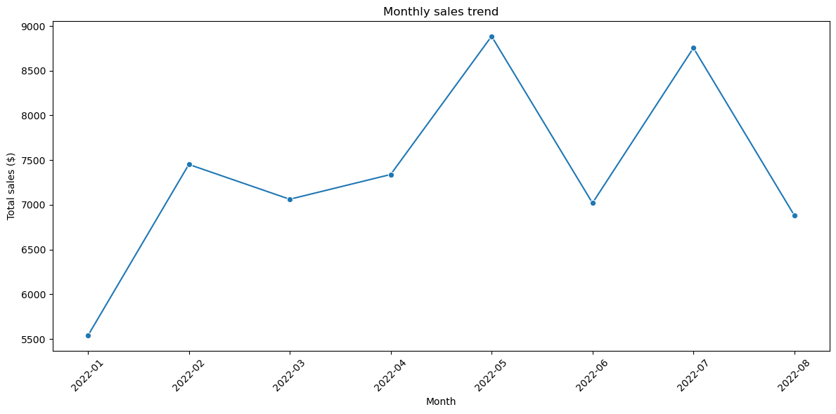

**🌍 Top Performing Countries**

Among all countries, the **USA dominated the market** with the highest total OTC sales, followed by the **UK**, **Canada**, and **India**.

|  |  |
| --- | --- |
|  |  |
|  |  |
|  |  |
| |  |  | | --- | --- | | **Country** | **Total Sales ($)** | | 🇺🇸 USA | $14,109.48 | | 🇬🇧 UK | $12,032.30 | | 🇨🇦  Canada | $11,967.08 | | 🇮🇳 India | $11,122.06 | | 🇦🇺 Australia | $9,698.37 | |  |

**Observation:** These five countries collectively represent the **majority of total sales**, suggesting they are strategic markets for OTC products.

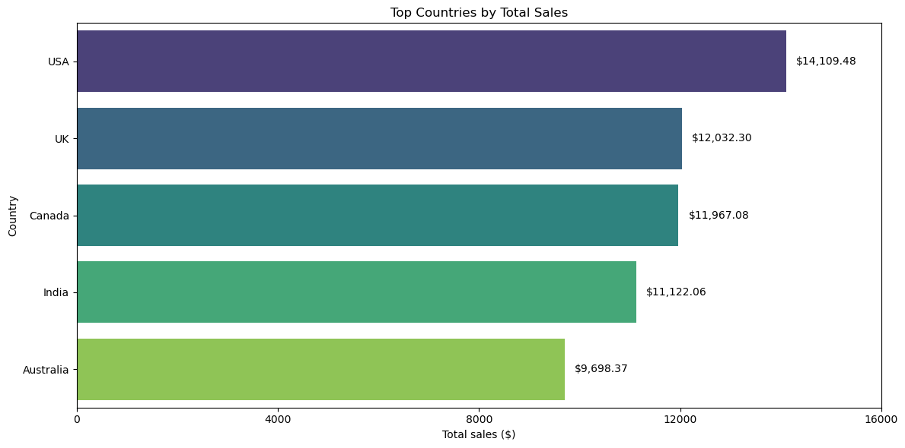

**🧑‍💼 Top Sales Representatives**

Sales performance also varied by representative.  
The leading performer, **Rajesh Patel**, achieved over **$11,000** in total sales, indicating strong customer relationships or successful marketing in his territories.

|  |  |  |  |  |  |  |  |  |  |  |  |  |  |
| --- | --- | --- | --- | --- | --- | --- | --- | --- | --- | --- | --- | --- | --- |
|  | |  |  | | --- | --- | | **Salesperson** | **Total Sales ($)** | | Rajesh Patel | $11,023.53 | | Nikhil Batra | $10,418.34 | | Priya Singh | $9,121.78 | | Ritika Shah | $7,945.97 | | Aman Verma | $7,039.07 | |
|  |  |

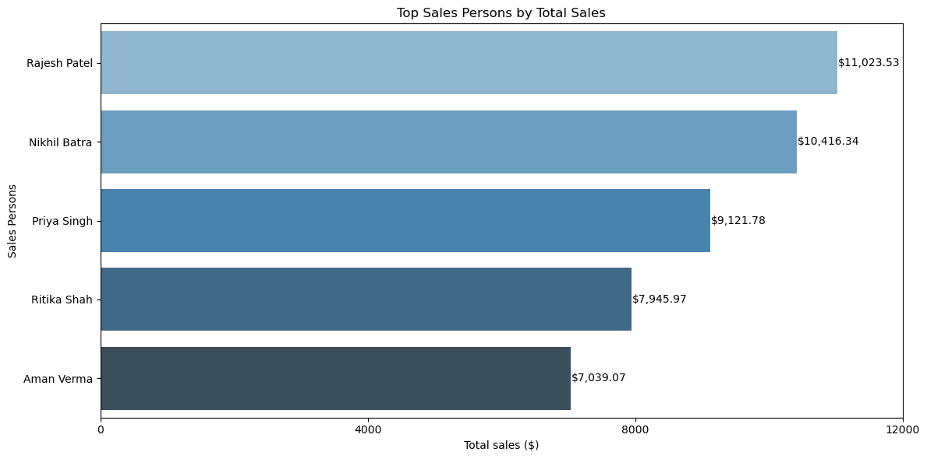

**💼 Best-Selling Products**

When analyzing product-level performance, **Digestive Enzyme** emerged as the top-selling product both in terms of **quantity shipped** and **total revenue**:

|  |  |  |  |  |  |
| --- | --- | --- | --- | --- | --- |

|  |  |  |  |
| --- | --- | --- | --- |
| **Product** | **Boxes Sold** | **Boxes Sold(%)** | **Total Sales ($)** |
| Digestive Enzyme | 612 | 17.5 | 11,056.61 |
| Antiseptic Cream | 573 | 16.4 | 9,736.28 |
| Nasal Spray | 489 | 14.9 | 8,407.36 |
| Eye Drops | 458 | 14.0 | 8,036.36 |
| Cough Syrup | 484 | 13.9 | 7,917.01 |
| Allergy Pills | 518 | 13.1 | 7,782.58 |
| Pain Relief Tablets | 354 | 10.1 | 5,993.09 |

**Insight:** These products may reflect common seasonal illnesses or chronic demand, making them ideal for targeted promotions.

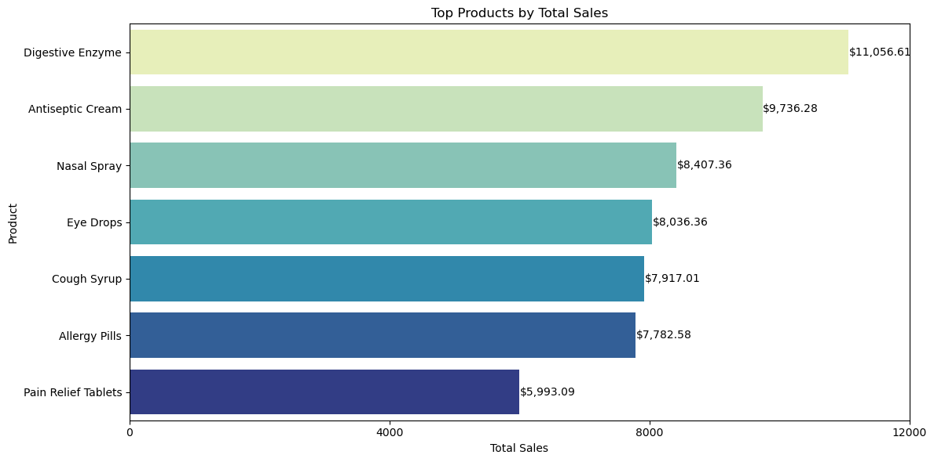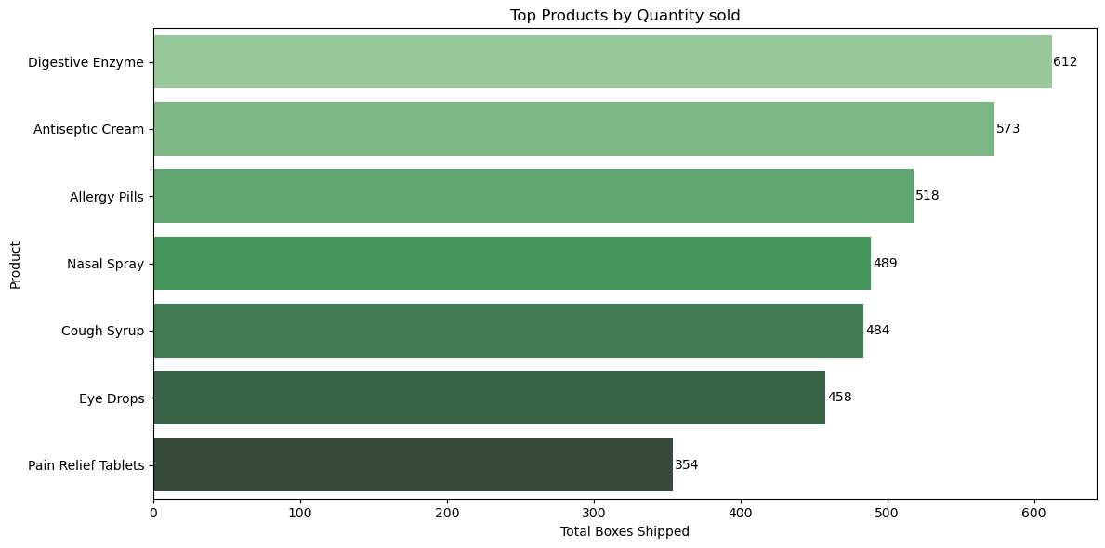

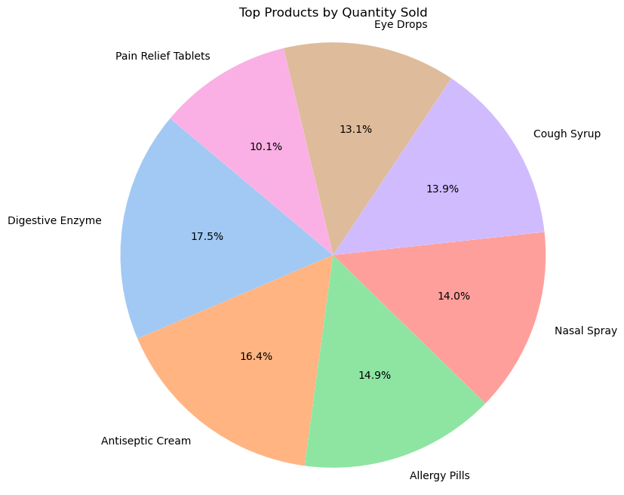

**🔮 Future Insights & Recommendations**

* **Market Expansion:** Given the sales dominance in the US and UK, expanding inventory or promotions in these regions may further boost profits.
* **Salesperson Training:** Encourage skill sharing from top performers like Rajesh Patel to enhance overall team results.
* **Product Strategy:** Inventory focus should prioritize Digestive Enzymes, Antiseptic Creams, and Nasal Sprays based on consistent demand.
* **Predictive Opportunity:** A basic time series forecast suggests that with the current trend, the final quarter of the year could exceed **$60,000** in cumulative sales if momentum is maintained.

**🙋‍♂️  Author**

**Name**: Mohamed Ournani  
**Role**: Data Analyst  
**Contact**: [LinkedIn](https://www.linkedin.com/in/mohamed-ournani-9871722a1) | [GitHub](https://github.com/mohamed200025) | [Fiverr](https://www.fiverr.com/users/mohamed_ournani)